BIGMART SALES PREDICTION USING MACHINE

LEARNING
Project report submitted impartial fulfillment of the requirement for Data Science and Gen AI Course
By

Abhishek Suresh Naik

Under the supervision of

Arun
Trainer(Teaching Faculty)



We are really grateful and wish our profound in debtedness to Trainer
Shree Arun Teaching Faculty @ Imartics learning Institute. Deep Knowledge & keen interest of my supervisor in the field of ML to carry out this project. Her endless patience, scholarly guidance, continual encouragement, constant and energetic supervision, constructive criticism, valuable advice, reading many inferior drafts and correcting them at all stages have made it possible to complete this project.
We would also generously welcome each one of those individuals who have helped me straight forwardly or in a round about way in making this project a win. In this unique situation,.
Finally, we must acknowledge with due respect the constant support and patients of our parents.

TABLEOFCONTENTS

CHAPTER1:INTRODUCTION

Introduction 01
Problem Statement 02
Objectives 03
Methodology Used 04
CHAPTER2:LITERATURE SURVEY
Literature survey 05
CHAPTER3:SYSTEMDEVELOPMENT
Algorithms employed 07
Phase of model 12
CHAPTER4:PERFORMANCEANALYSIS
Performance comparison 40
CHAPTER5:CONCLUSIONS
Conclusions 44
Future Scope 44

LISTOFABBREVIATIONS

ABBREVIATION | WORD
ML | MACHINELEARNING
EDA | EXPLORATORYDATAANALYSIS
FIG | FIGURE
DESCR | DESCRIPTION
RF | RANDOMFOREST
LR | LINEARREGRESSION
CSE | COMPUTERSCIENCEAND ENGINEERING

ABSTRACT
Now a days many shopping malls keep track of individual item sales data in order to forecast future client demand and adjust inventory management. In order to be ahead of the competition and earn more profit one needs to create a model which will help to predict and find out the sales of the various product present in the particular store. So to predict out the sales for the big mart one need to use the very important tool i.e. Machine Learning(ML). ML is that field of computer science which gives machines I e computers the ability to learn without doing any type of programming. Using the concepts of machine and basics of data science one can build a model which can help to predict the sales of the big mart. Because of increasing competition among various shopping complex one needs to have some predictive model which could help to gain some useful insights so as to maximize the profit and be ahead of the competitors.

Chapter 1 INTRODUCTION

INTRODUCTION
The daily competition between different malls as well as big malls is becoming more and more intense because of the rapid rise of international supermarkets and online shopping’s. Every mall or mart tries to provide personal and short-term donations or benefits to attract more and more customers on a daily basis, such as the sales price of everything which is usually predicted to be managed through different ways such as corporate asset management, logistics, and transportation service, etc. Current machine learning algorithms that are very complex and provide strategies for predicting or predicting long-term demand for a company’s sales, which now also help in overcoming budget and computer programs.
In this report, we basically discuss the subject of specifying a large mart sale or predicting an item for a customer’s future need in a few supermarkets in various locations and products that support the previous record. Various ML algorithms such as linear regression, random forest, etc. are used to predict sales volume. As we know, good marketing is probably the life blood of all organizations, so sales forecasting now plays an important role in any shopping mall. It is always helpful to predict the best, and develop business strategies about useful markets and to improve market knowledge. Regular sales forecasting research can help in-depth analysis of pre-existing conditions and conditions and then, assumptions are often used in terms of customer acquisition, lack of funding, and strength before setting budgets and marketing plans for the coming year.
In other words, sales forecasts are predicted on existing services of the past. In-depth knowledge of the past is required to develop and enhance market opportunities no matter what the circumstances, especially the external environment, which allows to prepare for the future
Needs of the business. Extensive research is ongoing in the retailer’s domain to predict long-term sales demand. An important and effective method used to predict the sale of a mathematical method, also called the conventional method, but these methods take more time to predict sales. And these methods could not manage indirect data so to overcome these problems in traditional methods the machine learning techniques used. ML methods can handle not only indirect data but also large data sets well.

PROBLEM STATEMENT
Due to increasing competition many malls and big mart are trying their best to stay ahead in competition. In order to find out what are the various factors which affect the sales of big mart and what strategies one needs to employ in order to gain more profit one need to have some model on which they can rely .So a predictive model can be made which could help to gain useful information and increase profit.

OBJECTIVES

Objectives of these project are:

- Predicting future sales from a given dataset.

- To understand the key features that are responsible for the sale of a particular product.

- Find the best algorithm that will predict sales with the greatest accuracy.

METHODOLOGY

Figure1.1represents the steps of building a model.Following are the steps which one needs to follow while creating a model.

Fig1.1:Process of building a model.

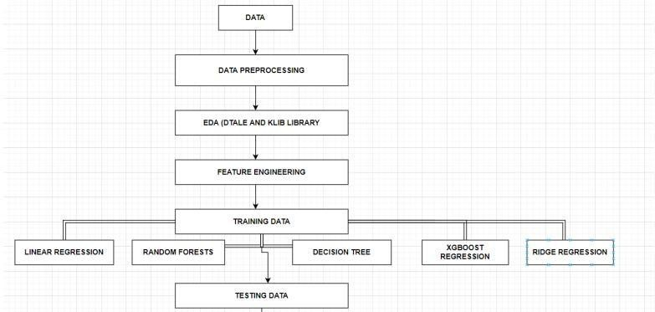
Fig1.2:Working procedure of proposed model

    - Data collection- The step of every project is to collect the data.

We collected our data from the Kaggle whose link is given below-https://www.kaggle.com/brijbhushannanda1979/bigmart-sales-data/code
    - Data preprocessing-In this step we basically clean our dataset for example check for any missing value in the dataset , if present then handle the missing values. In our dataset attributes like Item Weight and Outlet Size had the missing value.

    - EDA-This part is considered as one of the most important parts when it comes to data analysis. To gain important insights of our data one must need to do exploratory data analysis. Here in our project we used two libraries i.e. Matplotlib and Seaborn library.

    - Tested various algorithms-Then various algorithms like simple LR, xgboost algorithm were applied in order to find out which algorithm can be used to predict the sales.

    - Building the model -After completing all the previous phases which are mentioned above, now our dataset is ready for further phases that is to build the model.
Once we built the model now it is ready to be used as a predictive model to forecast sales of Big Mart.

CHAPTER 3 SYSTEM DEVELOPMENT

ALGORITHMS EMPLOYED
LINEARREGRESSION(LR)

As we know Regression can be termed as a parametric technique which means we can predict a continuous or dependent variable on the basis of a provided datasets of independent variables.
The Equation of simple LR is:

Y=βo+β1X+∈ (1)

where,

Y:It is basically the variable which we used as a predicted value. X : It is a variable(s) which is used for making a prediction.
βo:It is said to be a prediction value when X=0.

β1: when there is a change in X value by 1 unit then Y value is also changed. It can also be said as slope term ∈

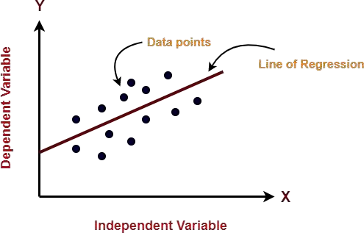

Fig 3.1Given figure represent line of regression

RANDOM FOREST REGRESSION

Random Forest is a tree-based bootstrapping algorithm based on that tree that includes a certain number of decision trees to build a powerful predictive model. Individual learners, a set of random lines and a randomly selected few variables often create a tree of choice. The final prediction may be the function of all predictions made by each learner. In the event of a regression. The final prediction may be the meaning of all the predictions.

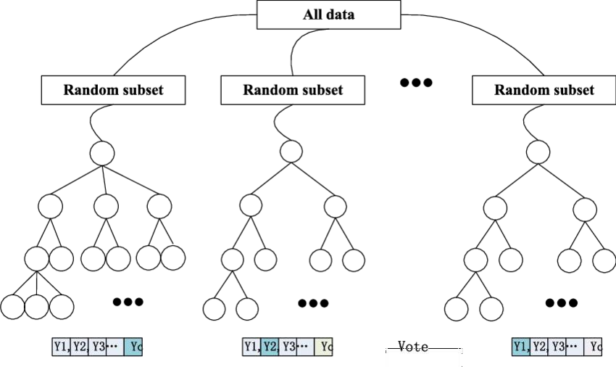
Fig3.2:Flow chart of Random Forest Regression

HYPER PARAMETERTUNING

In ML, optimization of the hyper parameter or problem solving by selecting the correct set of parameters for the learning algorithm. To control the learning process a hyper parameter parameter value is used. In contrast, the values of some parameters are calculated.
The same type of ML model may require different types of weights, learning scales or constraints in order to make different data and information patterns more general. The steps are also called hyper parameters and must be used for the model to solve the ML problem.

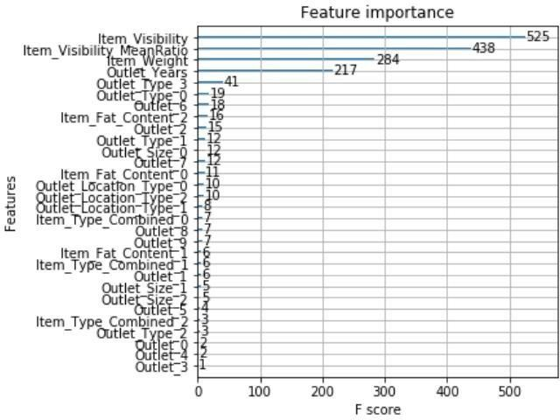

Fig3.3:Relationship between Feature Importance and their F score in Hyper parameter tuning

XGBOOSTREGRESSION

XGBoost stands for eXtreme Gradient Boosting. The implementation of an algorithm designed for the efficient operation of computer time and memory resources. Boosting is a sequential process based on the principle of the ensemble. This includes a collection of lower learners as well improves the accuracy of forecasts. No model prices n heavy for any minute t, based on the results of the previous t-speed. Well-calculated results are given less weight, and the wrong ones are weighed down. With this algorithm system

The XGBoost model uses stepwise, ridge regression internally, automatically selecting features as well as deleting multi co linearity.

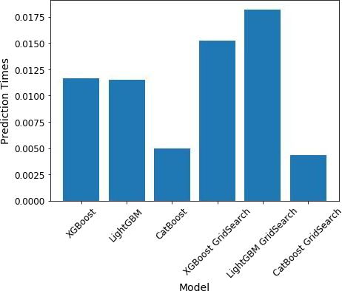

Fig3.4:Represents the types of XGBoost regression

PHASE OF MODEL

DATA AND ITS PREPROCESSING

In our work, we have used the 2013 Big Mart sales data as a database. Where the data set contains 12features such as ItemFat,ItemType, MRPItem, Output Type, Object Appearance, Object Weight, Outlet Indicator, Outlet Size, Outlet Year of Establishment, Type of Exit, Exit Identity, and Sales. In these different aspects of responding to the Item Outlet Sales features as well, the other features are also used as the predictive variables. Our dataset has in total 8523 products in various regions and cities. The data set is also based on product level and store-level considerations . Where store level includes features such as city, population density,
Store capacity, location ,etc. and product-level speculation involves factors such as product, ad, etc. After all considerations, a data set is finally created, then the data set is split into two parts that are tested and trained in a ratio of 80:20.

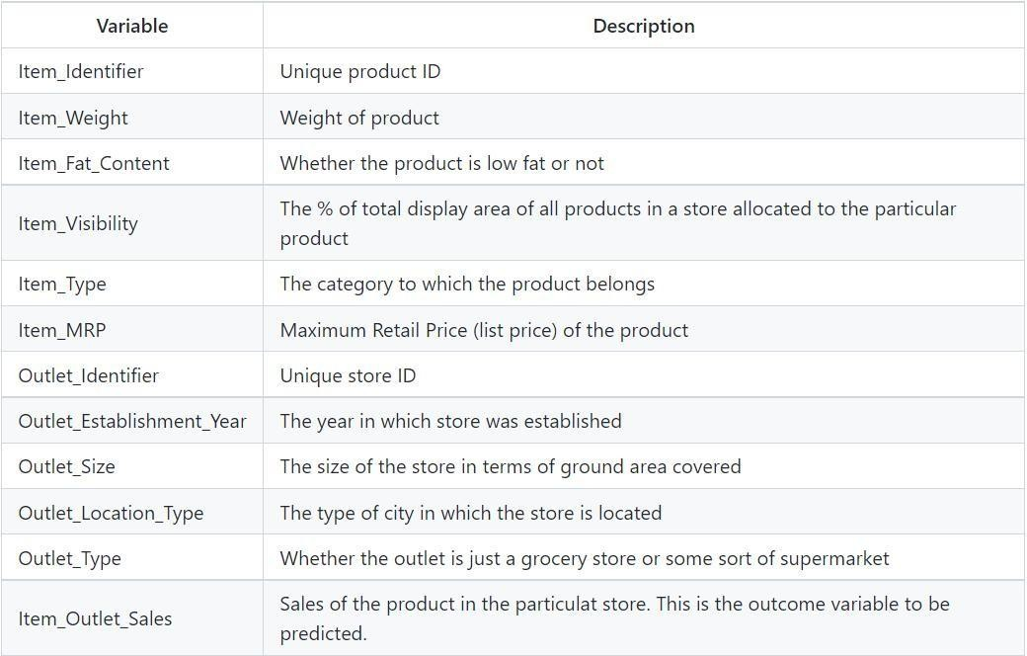

Fig3.5:Depicting the features of the dataset

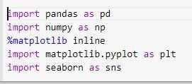

Fig3.6:How libraries, train and test data sets are imported.

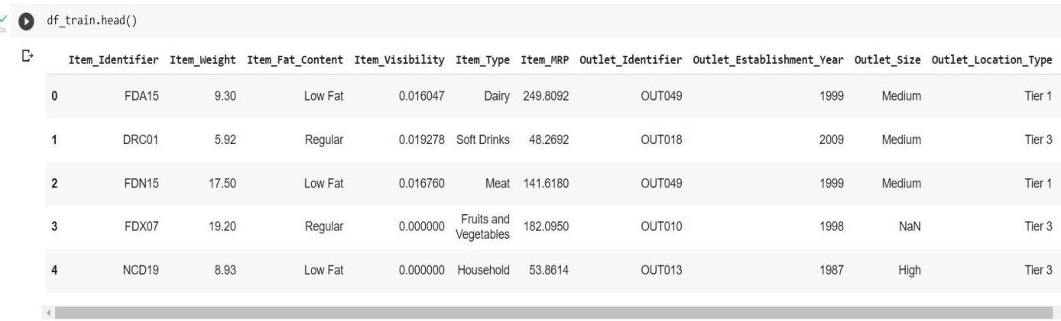

Fig3.7Head function representing first five dataset

Item Visibility has a value = 0 as values which have no meaning, Item_Identifier is a characterstring with some specific code used by the bigmart and Outlet_Size contains some missing values as well.

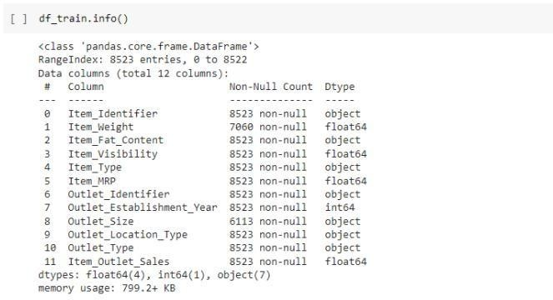

Fig3.8:Description of dataset using info() method

In figure 3.8 we can clearly see that there are in total 12 features out of whichNumeric data count is5 and Categorical data count is 7.

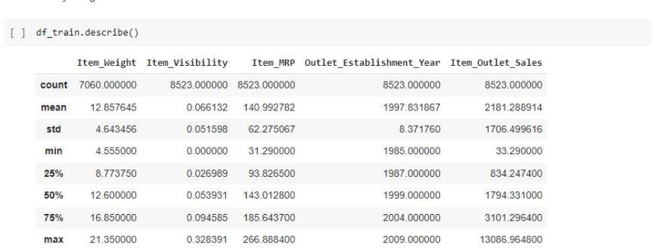

Fig3.9:Description of dataset using describe() method

Infigure3. Item Visibility feature has a minimum value of 0.00and Item_weight has count of 7060.

HANDLING MISSING VALUES

While analyzing the dataset we come across some missing values in the dataset. In order to check for the missing value we have the following code-

Fig3.10Depictsthenumberofmissing value
bm.isnull().sum()
Item_Identifier Item_Weight Item_Fat_Content Item_Visibility Item_Type Item_MRP Outlet_Identifier
Outlet_Establishment_Year Outlet_Size Outlet_Location_Type Outlet_Type Item_Outlet_Sales
dtype:int64
0
1463
0
0
0
0
0
0
2410
0
0
0

From the above Fig 3.10 we can clearly see that column names item_weight and outlet_size have 1606
And 2410 missing values respectively.
In order to handle these missing values we have different approaches for e.g. dropping the rows having missing value or filling the missing value with suitable values using different methods. Looking at our dataset we have 8523 rows so dropping would not be a better option as it would lead to decrease the prediction accuracy.

#imputing item weight based on item identifier mean
item_weight_mean=bm.pivot_table(values='Item_Weight',columns='Item_Identifier',aggfunc='mean')
missing_weights=bm["Item_Weight"].isnull()
bm.loc[missing_weights,"Item_Weight"]=bm.loc[missing_weights,"Item_Ide ntifier"].apply(lambda x : item_weight_mean[x].values[0] if x in item_weight_mean else bm['Item_Weight'].mean())

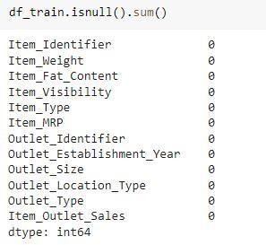

So finally-

Fig3.14:Nowthere are nomissingvaluesintheitem_weightandOuter_sizecolumns.

EDA

      - EDA WITHDTALELIBRARY

D-TaleisaFlaskandReact-basedpowerfultoolwhichisusedtoanalyzeandvisualize pandas' data structure seamlessly.
D-TalealsosupportsobjectslikeDataFrame,Series, etc.

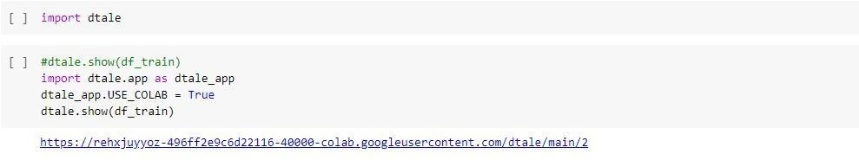

Fig3.15:Representshowtoimportdtalelibraryand displaythetable

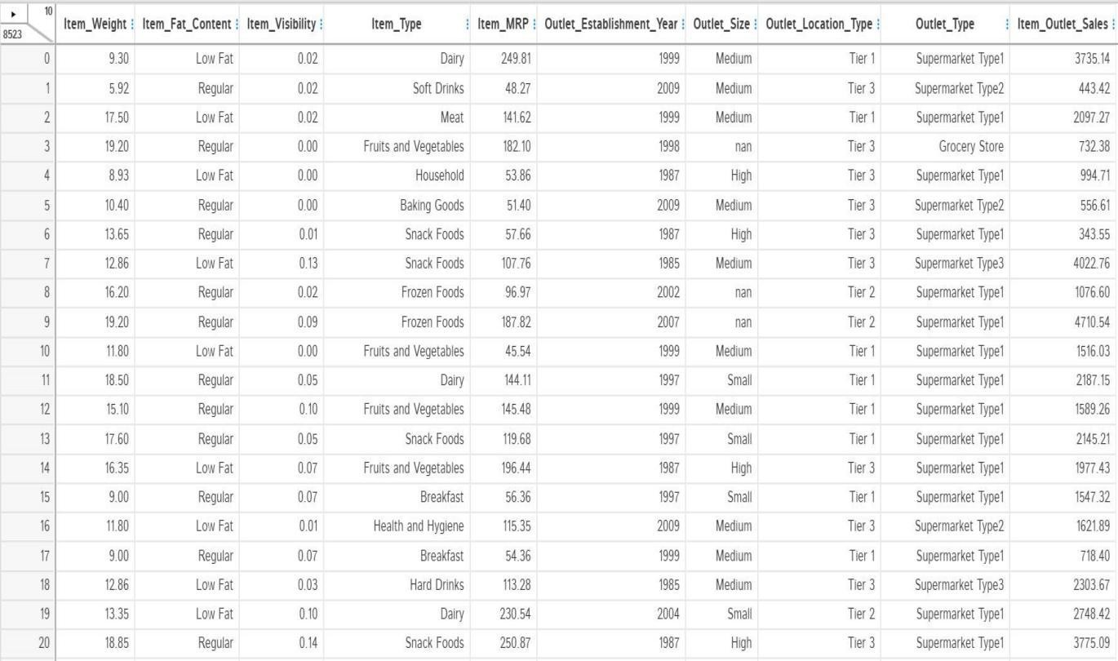

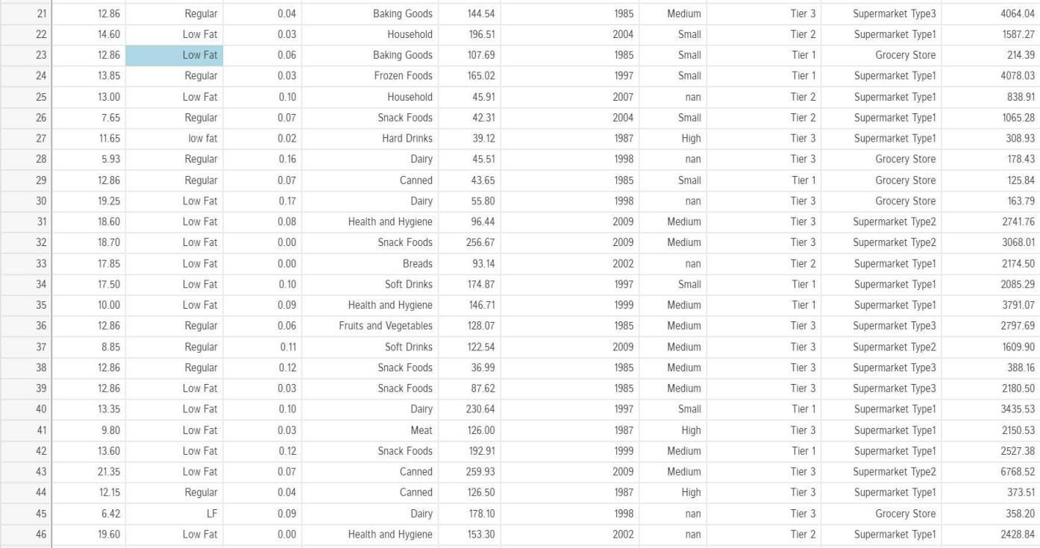

Fig3.16:TheDtaleWindow

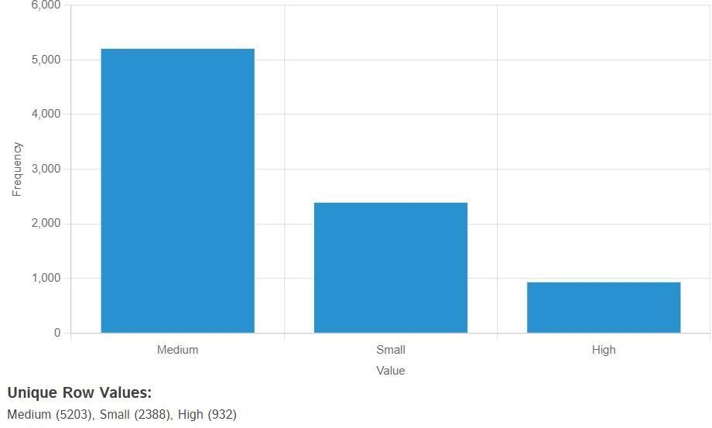

Fig3.17:FrequencyofvaluesinthecolumnnameOutlet_Size

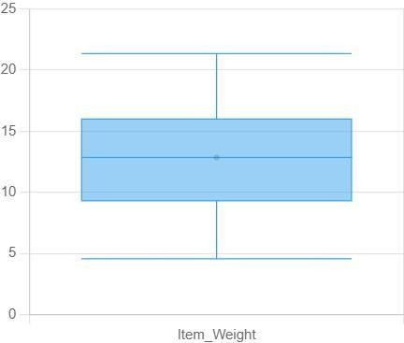

Fig3.18:ThisfigurerepresentstheItem_Weightvalue range

EDAUSINGKLIBLIBRARY

Klib is a pythonlibrary which is used for importing, cleaning,analyzing andpreprocessing the data.

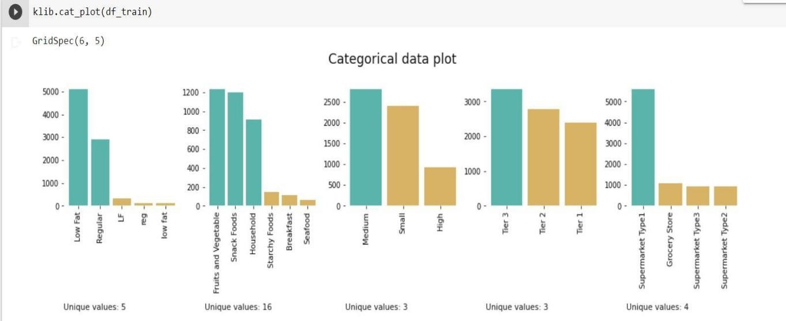

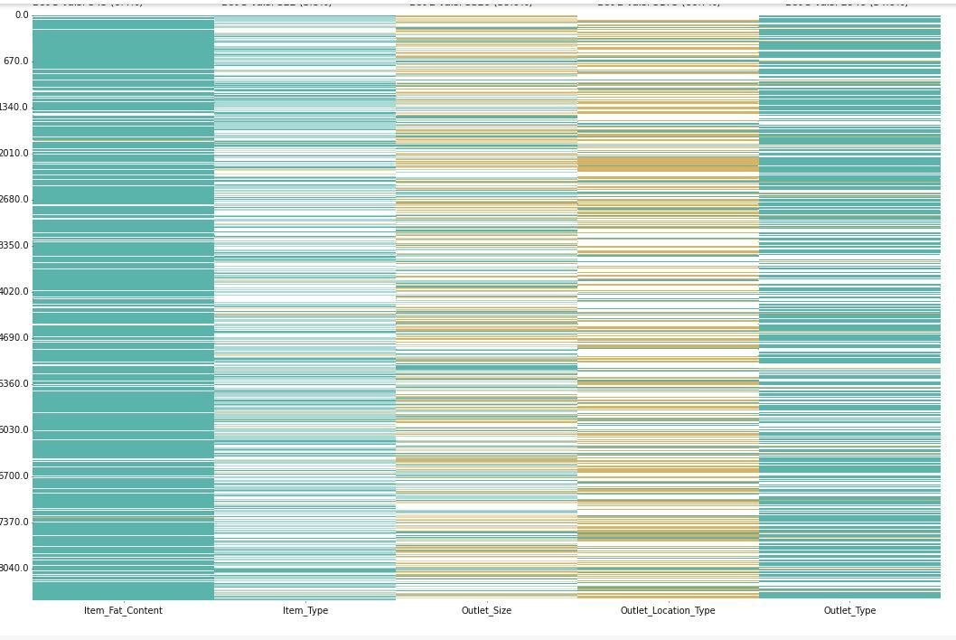

Fig3.19:Categoricaldataplotofallvariablespresentindataset usingKlibLibrary

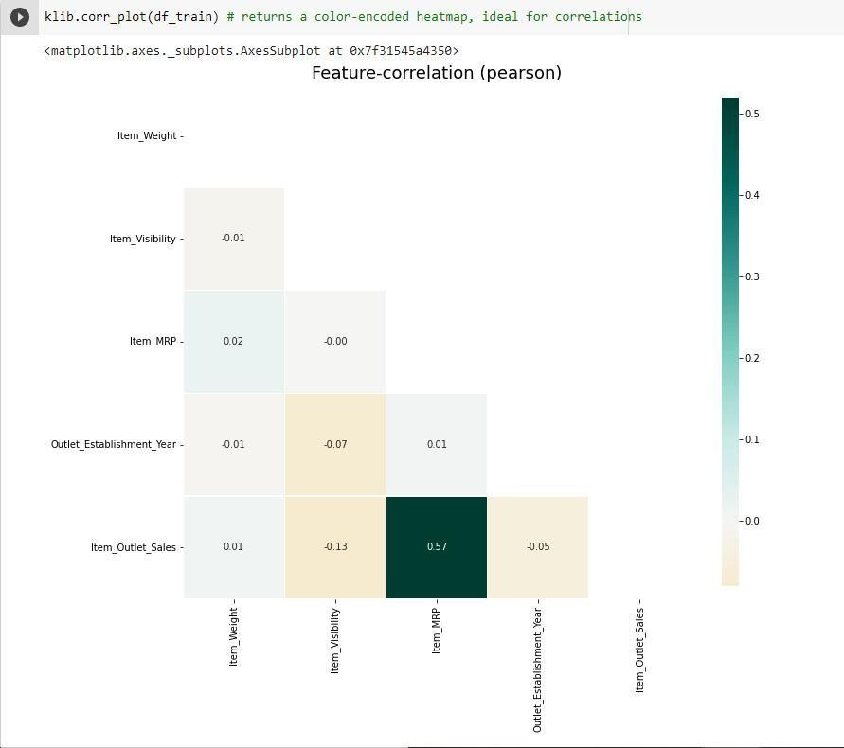
Fig3.20:Feature-correlationusingklibLibrary

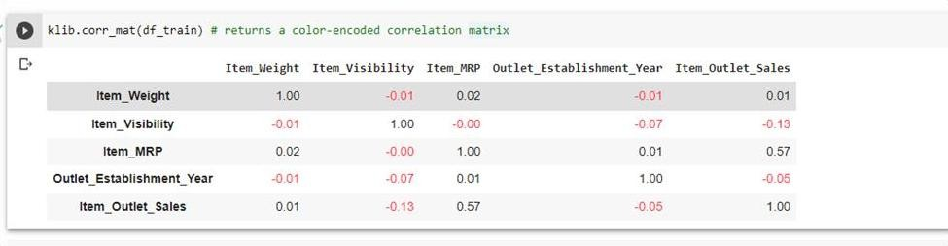
Fig3.21:Color-encodedcorrelationmatrix.

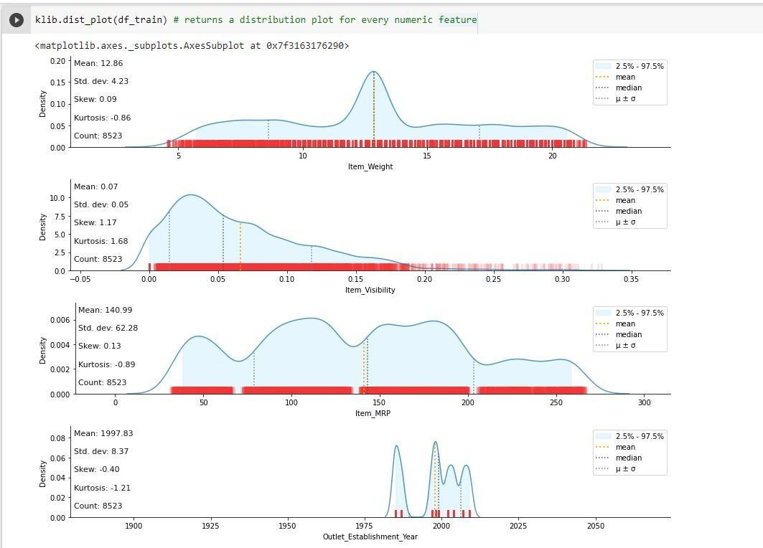

Fig3.22:Distributionplotforeverynumeric feature.

      - EDAWITHSEABORNLIBRARY-Seabornisadatavisualizationlibrarybuilton top of matplotlib

-
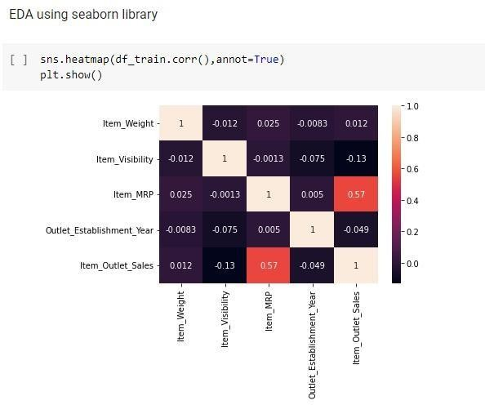

Fig3.23:Correlationbetween differentfeatures

From the figure 3.23 we can clearly see that item_visibility attribute has thelowest correlationwiththeothertargetvariablesandItem_MRPhasstrongpositivecorrelationwith target variables i.e. 0.57.

DATACLEANINGUSINGKLIBLIBRARY

Datacleaningisbasicallytheprocesswherethecorruptrecordset,tablesordatabases are detected and then corrected by replacing, modifying, or deleting the dirty or coarse data.

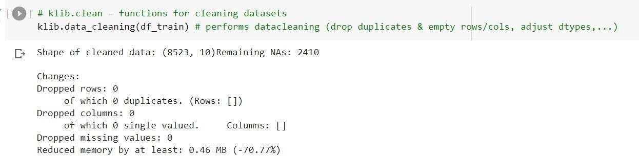

Fig3.24:Cleaningthedatausingkliblibrary

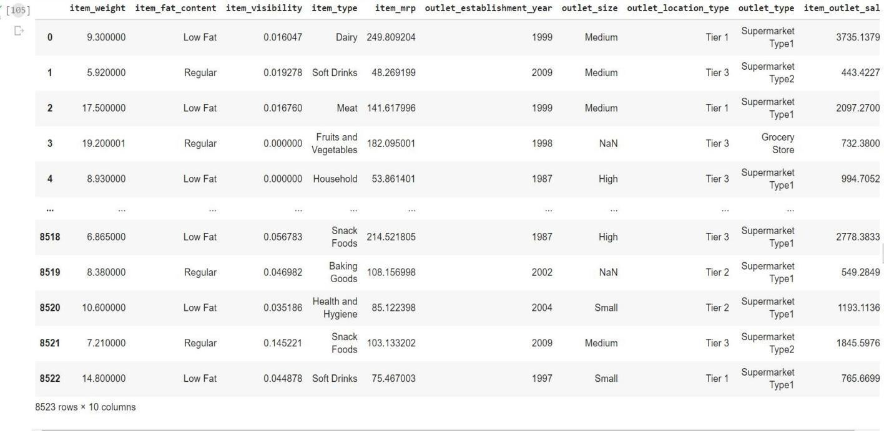

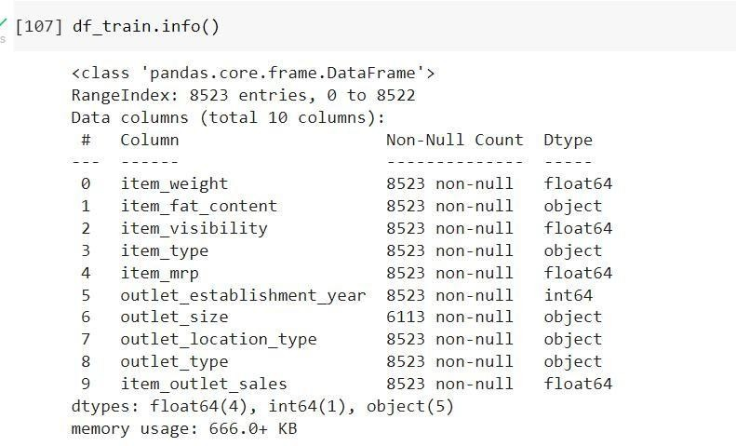

Fig3.26:Representsthe12featuresofthedatasetienumericalandcategorical

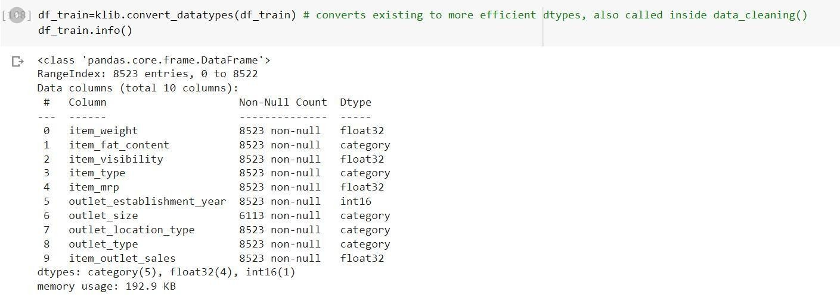

Fig3.27:Convertingtomoreefficientdatatypesusingconvert_datatypesfunction

FEATUREENGINEERING

Feature Engineering is a way of using domain data to understand how to build mechanical operations learning algorithms. When feature engineering is done properly, the ability to predictMLalgorithmsaredeveloped bycreatingusefulraw datafeaturesthatsimplifytheML process. Feature engineering including correction of incorrect values. In the device database, object visibility has a small value of 0 which is unacceptable, because the object must be accessible to all, and so it is replaced by the mean of the column.

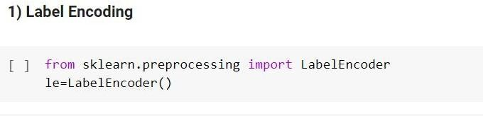
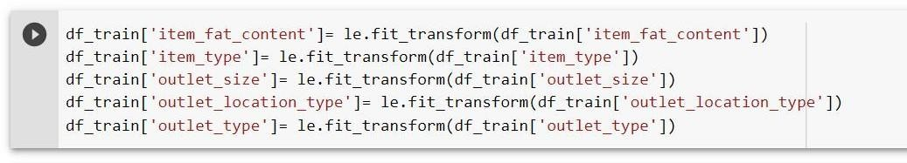

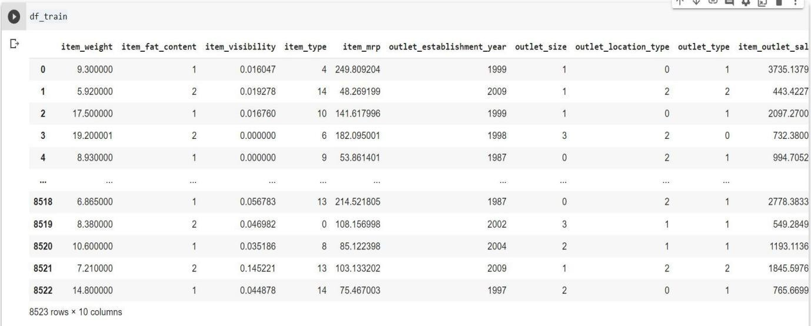

Fig3.28:LabelEncodingCode

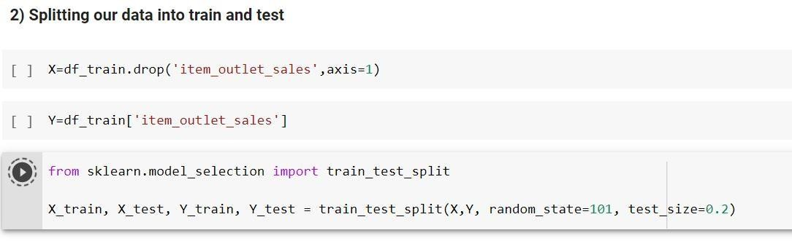
Fig3.29:Splittingofdataintotrainandtestdataset.

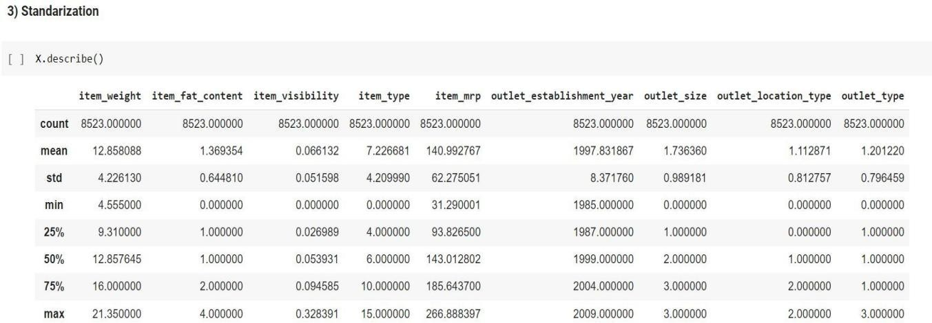

Fig3.30:Standardizationofdataset

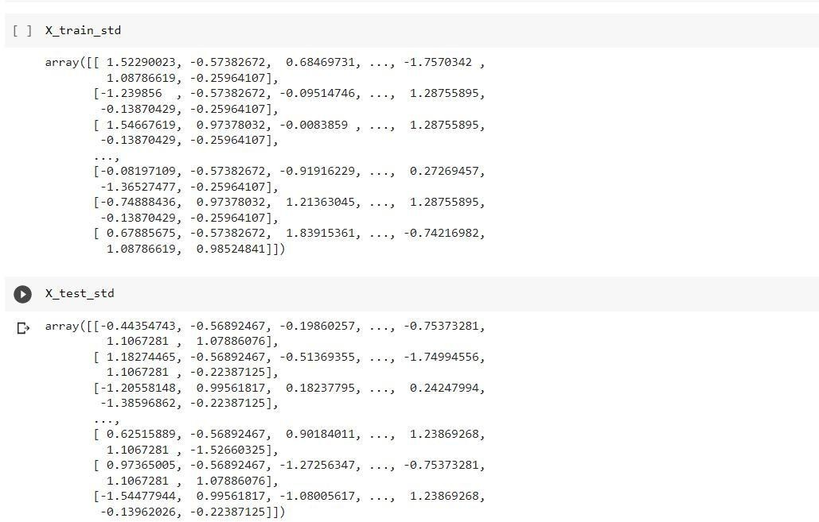

Fig3.31X_train_stdarrayandX_test_stdarray

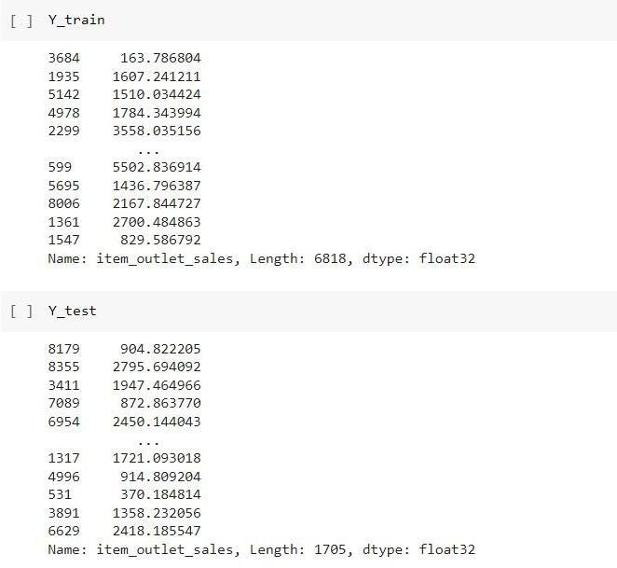

Fig3.32Y_trainarrayandY_testarray

Infigures3.33and3.34wejustsplitthetrainandtestdataintoX_train_std,Y_train, X_test_std and Y_test.

MODELBUILDING

Now the dataset is ready to fit a model after performing Data Preprocessing and Feature Transformation. The training set is fed into the algorithm in order to learn how to predict values. Testing data is given as input after Model Building a target variable to predict. The models are built using:
      - LR
      - RFRegression
      - HyperParameterTuning
      - XGBoostRegression
      - DecisionTree
      - RidgeRegression

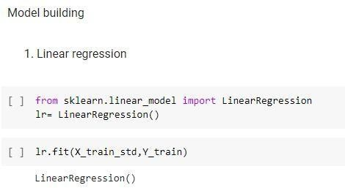

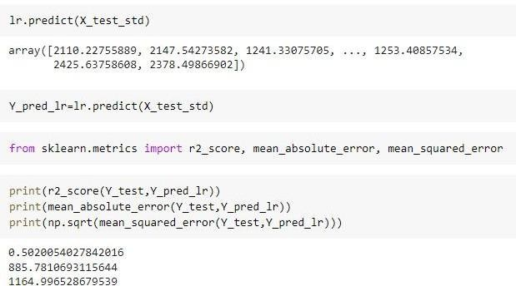

Fig3.35:ValueofR2inLinear Regression=0.50
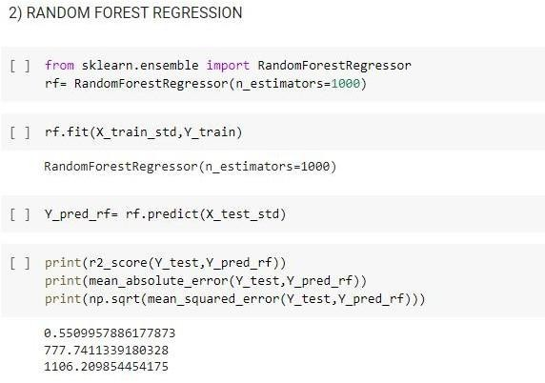

Fig3.36:Value ofR2inRandomForestRegression= 0.55

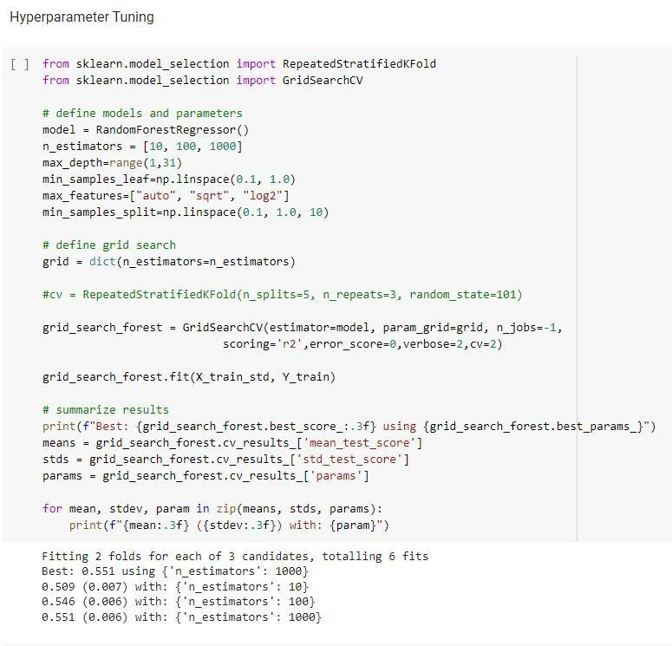
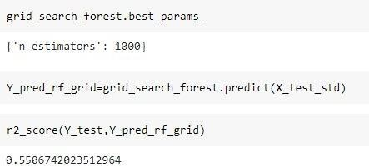

Fig3.37:ValueofR2=0.55

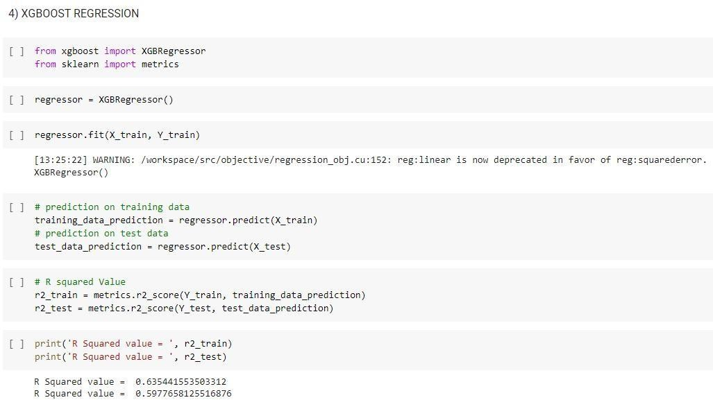

Fig3.38:Value ofR2inXGBoostRegression=0.63

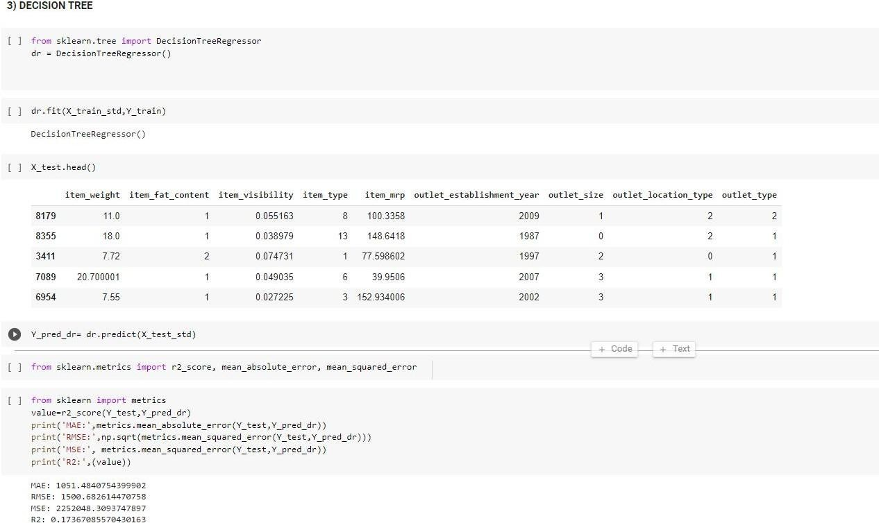

Fig3.39:Valueof R2inDecisionTree =0.17

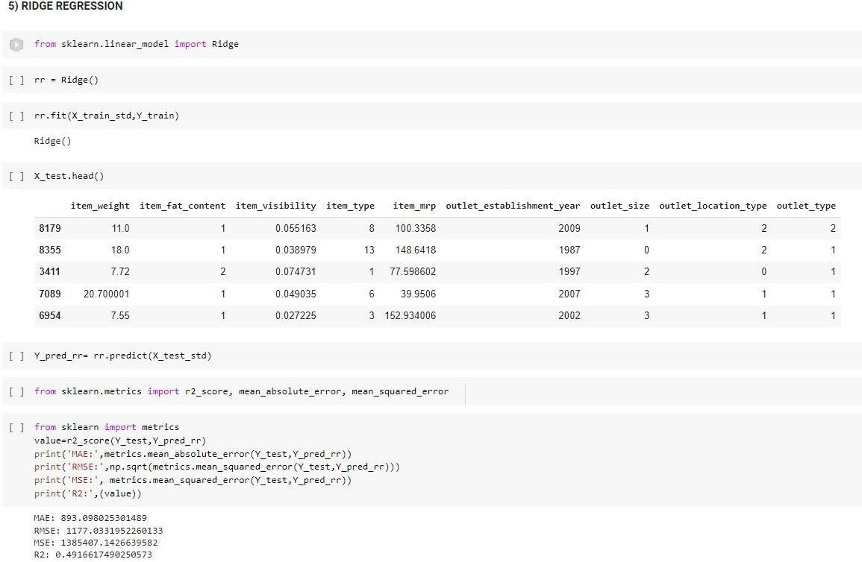

Fig3.40:ValueofR2inRidge Regression=0.4916

CHAPTER4

4.PERFORMANCEANALYSIS

For the purpose of performance analysis we can go and look for the R2value of the different algorithm performed and check for which algorithm gives us the best performance

LR
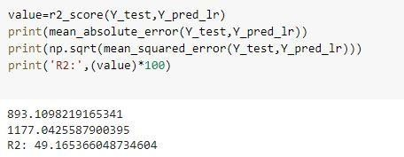

Fig4.1PerformanceofLinear Regression

RFregression

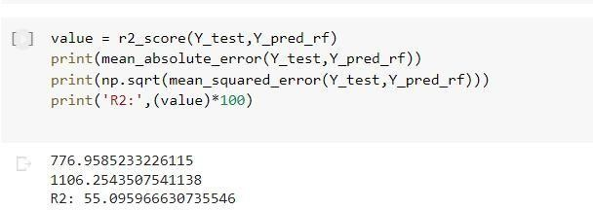

Fig4.2:PerformanceofRandomForestRegression

Hyperparameter tuning
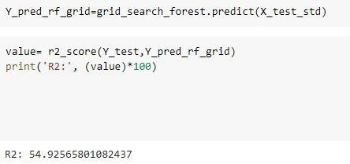

Fig4.3:PerformanceofHyperTuningParameter

DecisionTree

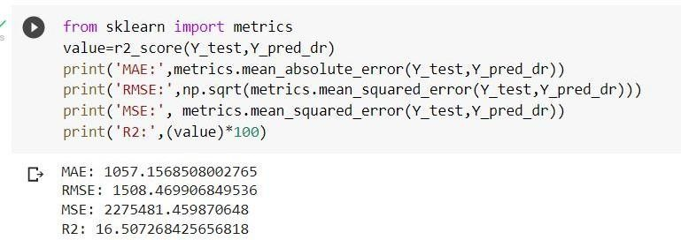

Fig4.4:PerformanceofDecisionTree

XGBoostRegression
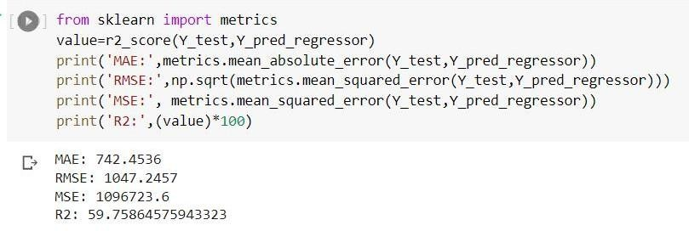

Fig4.5:PerformanceofXgBoostRegression

Ridge Regression

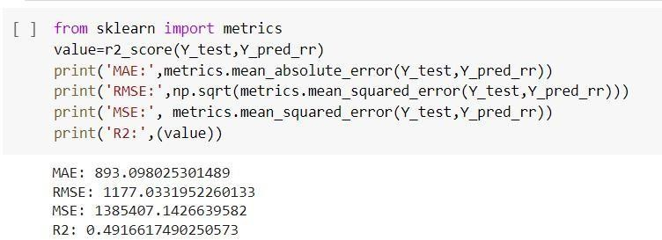

Fig4.6:Performanceof Ridge Regression

TABLE4.1:Algorithms Performance

ALGORITHM | R2 | RMSE | MSE
LinearRegression | 51.7 % | 1145.82 | 1312903.73
RandomForest Regression | 56.18 % | 1091.29 | 1190907.01
DecisionTree | 15.42 % | 1508.46 | 2298869.86
XGBoostRegression | 61.0 % | 1029.55 | 1059978.13
RidgeRegression | 51.7 % | 1145.8 | 1312864.13

To forecast Big Mart’s revenue, simple to advanced ML algorithms have been implemented, such as LR, Decision Tree, RF regression and XGBoost.

From the above table, we conclude that the XGBoost algorithm is more efficient and gives accurate and fast results.

PERFORMANCEANALYSISUSINGGRAPHS RMSE AND MSE VALUES
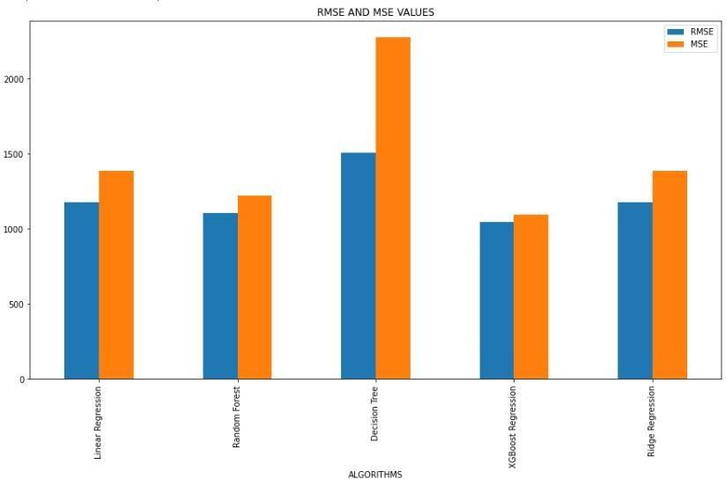
Fig4.7:Comparison of RMSE and MSE values for ML Algorithmsused

Figure 4.7 shows the comparative analysis of RMSE and MSE values. RMSE is the squared root of MSE and MSE is calculated by the squared difference between the original and predicted values in the data set. In this experiment Decision tree has the highest RMSE and MSE value andXgBoost Regression has the lowest RMSE and MSE value.

R2ANDMAEVALUES
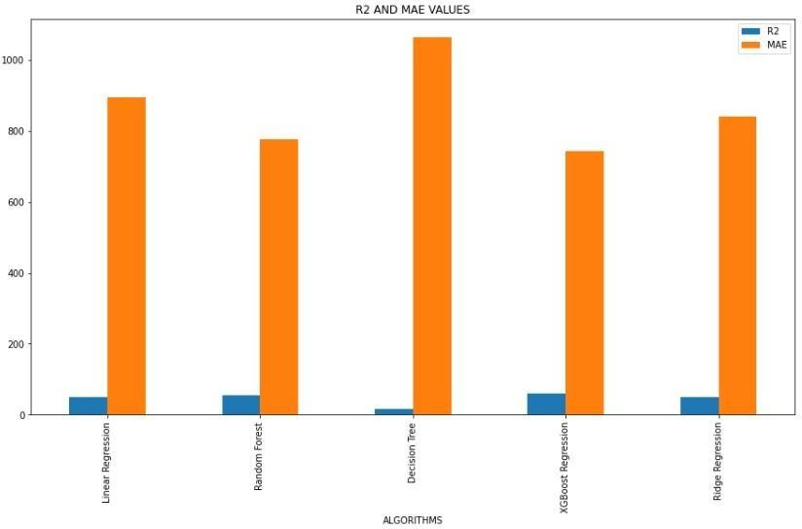
Fig4.8:ComparisonofR2andMAEvalues forMLAlgorithms used

Figure 4.8 shows the comparative analysis of R²and MAE values. MAE is calculated by the average of the absolute difference between the actual and predicted values in the dataset and R²iscalculatedbythesumoftheresidualssquared,andthetotalsumofsquaresisthesumof allthe data'sdeviationsfrom themean.In thisexperimentDecisiontree has thehighestMAE value whereas XgBoost has the lowest and in case of R²XgBoost has the highest value whereas Decision tree has the lowest value.

It has been observed that increased efficiency is observed with XGBoost algorithm with lower RMSE, MSE and MAE rating and higher R2rating

CHAPTER5

- .CONCLUSIONS

CONCLUSION

So from this project we conclude that a smart sales forecasting program is required to manage vast volumes of knowledge for business organizations.
The Algorithms which are presented in this report , LR, RF regression, Decision tree and XGBoost regression provide an effective method for data sharing as well as decision-making and also provide new approaches that are used for better identifying consumer needs and formulate marketing plans that are going to be implemented.
The outcomes of ML algorithms which are done in this project will help us to pick the for e most suitable demand prediction algorithm and with the aid of which BigMart will prepare its marketing campaigns.

FUTURESCOPE

The future scope of this project is that this project can further collaborate with any other devices which are supported with an in-built intelligence by virtue of the Internet of Things (I0T) which makes itmore feasible to use.
Multiple instances parameters and various factors are also make this sales prediction project more
innovativeandsuccessful.
The most important term for any prediction-based system that is accuracy, isoften significantly increased
because oftheincrease in thenumberofparameters.

6.REFERENCES

- Beheshti-Kashi, S., Karimi, H.R., Thoben, K.D., Lutjen, M., Teucke, M.: A survey on retail sales forecasting and prediction in fashion markets. Systems Science &Control Engineering 3(1), (2015), pp.154–161

- Bose, I., Mahapatra, R.K.: Business data mining ML perspective. Information & management 39(3),(2001), pp. 211–225

- Mitchell,T.M. ML and data mining. Communicationsof theACM, 42(11) , (1999), pp.30-36.

- Das, P., Chaudhury, S.: Prediction of retail sales of footwear using feedforward and recurrent neural networks. Neural Computing and Applications 16(4-5),(2007), pp. 491–502

- Punam, K., Pamula, R., Jain, P.K.: A two-level statistical model for big mart sales prediction. In: 2018 International Conference on Computing, Power and Communication Technologies (GUCON), IEEE (2018). pp. 617–620.

